Project Planning Phase

**Sprint Delivery Plan**

|  |  |
| --- | --- |
| Team ID | PNT2022TMID48924 |
| DATE | 05 November 2022 |
| Project Name | Project-Personal Assistance for Seniors who are Self Reliant |

**Product Backlog, Sprint Schedule and Estimation**

Use the below template to create product backlog and sprint schedule

|  |  |  |  |  |
| --- | --- | --- | --- | --- |
| **Sprint** | **Functional**  **Requirement (Epic)** | **User Story/Task** | **Story Points** | **Priority** |
| Sprint-1 | Intializing the Resources | Create an account in Open Weather API | 1 | LOW |
| Sprint-1 | Code in Software is written | Write a python script using the inputs given from OpenWeather  API | 2 | MEDIUM |
| Sprint-2 | Sending the software to cloud | The python code from sprint 1 should be sent to cloud so that  it is easily accessible | 1 | MEDIUM |
| Sprint-3 | Initialising the connection between hardware and cloud | The hardware should be intergrated for the easy access of the  cloud functions | 2 | HIGH |
| Sprint-4 | User input-output optimisation and error identification  and rectification | Rectify all the shortcomings/errors and initiate the  optimisation for better | 3 | HIGH |

**Project Tracker, Velocity & Burndown Chart:( 4 Marks)**

|  |  |  |  |
| --- | --- | --- | --- |
| Sprint | Total Story | Duration | Story Points |
| Sprint-1 | 20 | 6days | 20 |
| Sprint-2 | 20 | 6days | 20 |
| Sprint-3 | 20 | 6days | 20 |
| Sprint-4 | 20 | 6days | 20 |

**Velocity :**

The average velocity(AV) per iteration unit (story points per day) can be defined as sprint duration by velocity (points per sprint)

AV= Sprint duration**/**Velocity

***Given:***

Sprint duration= 6days Velocity= 20

AV = 6/20

= 0.3



AV = 0.3

**Burndown chart:**

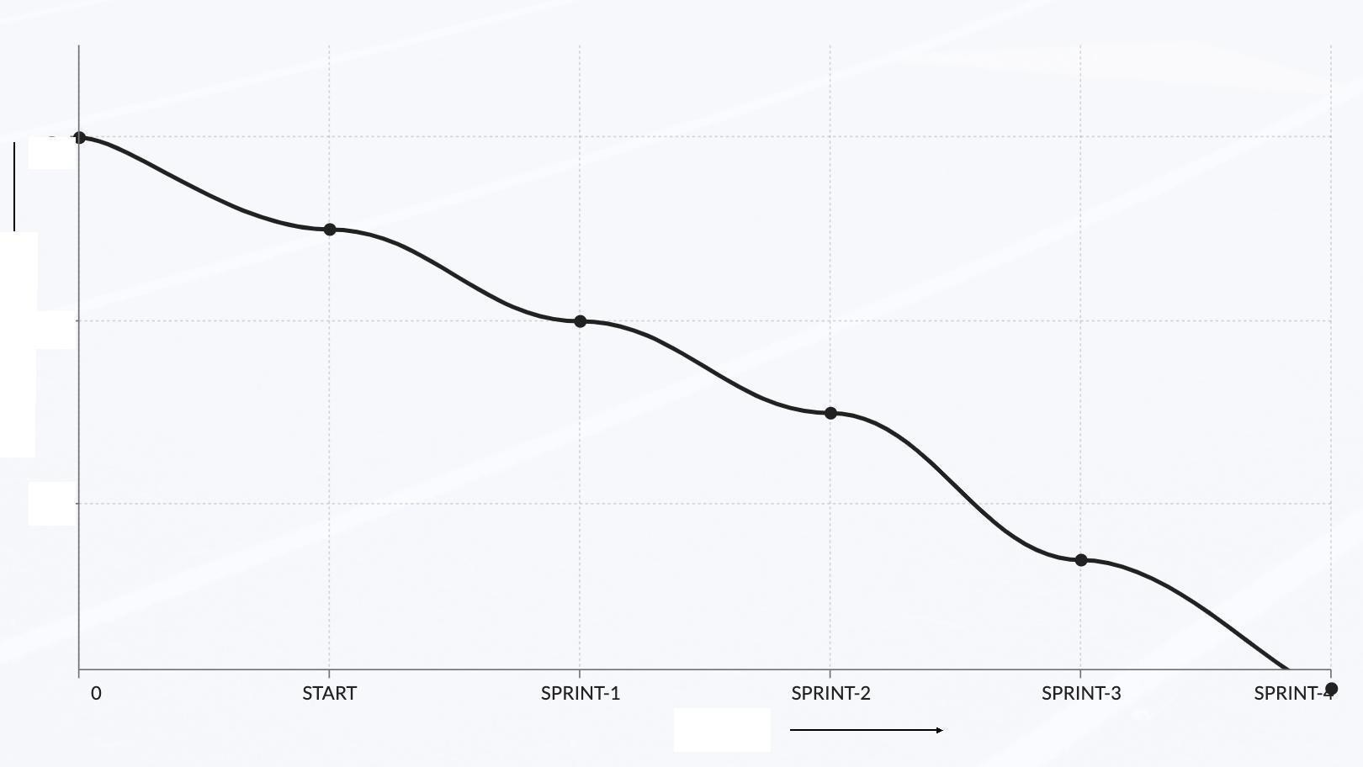

100

W or kR e m aini n g

50

25

Sprint